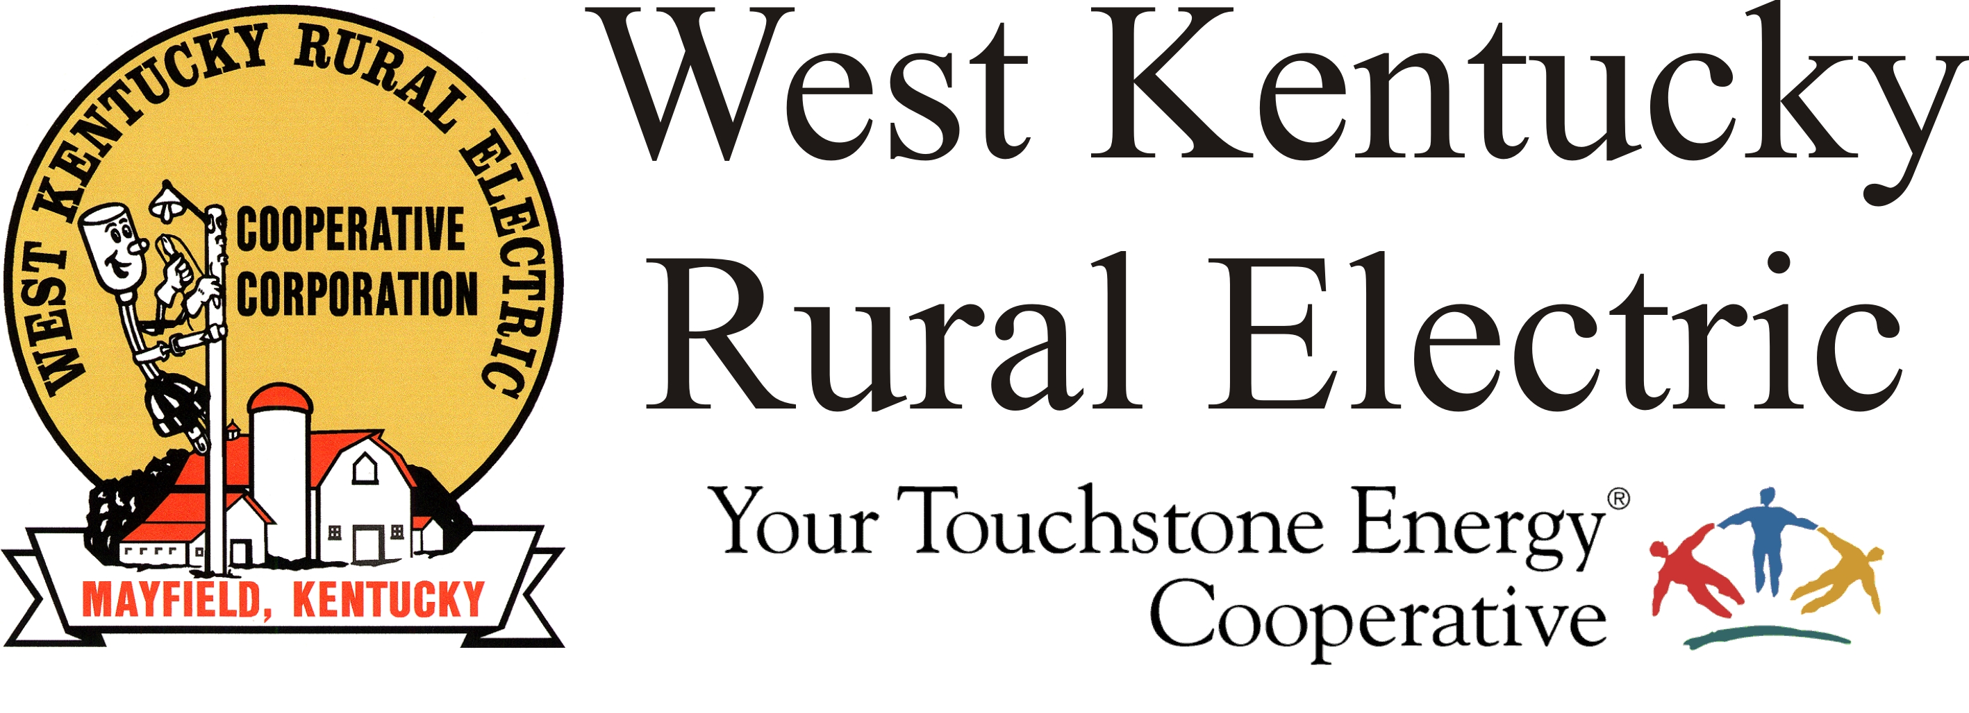

West Kentucky RECC Sunday Afternoon
Storm Damage Update

(Mayfield, Ky.) Dec. 12, 2021 (9:00 p.m.) – This has been a very positive day for our storm recovery effort. Tonight we have about 6,500 members with no electricity, down from a high of about 28,000.

Our lineworkers, visiting crews and contractors continue to do amazing work, rebuilding those sections of our service area shredded by the massive tornado. Our support team is there every step of the way, everyone from engineers, to dispatch, to the amazing team producing meals and other support.

We are showing that, together, we can meet the challenge of this enormous recovery.

Reminders:

- Our business offices will be closed Monday but we will be taking phone calls at 1-877-495-7322.

- If you need to report an outage or have a question about your service, email wkreccpower@gmail.com. We will let you know when phone reporting is back in service.

- Graves County members are asked to please conserve energy overnight.

We are very grateful tonight for the kindness, generosity and goodness of the communities we serve.
###

Georgann Lookofsky
270-804-1701
glookofsky@wkrecc.com

